Integrated Science
BECE 2022 — Paper 1 (Objective)
1. An example of a storage pest is
A. yam beetle.
B. capsid.
C. army worm.
D. weevil.
2. The number required to make the following chemical equation balanced is:
H₂ + O₂ → H₂O
A. 1/2.
B. 1.
C. 1/3.
D. 3.
3. Which of the following bodies are natural sources of light?
I. Moon
II. Sun
III. Glow worm
A. I and II only.
B. I and III only.
C. II and III only.
D. I, II and III.
4. An atom ²³₁₁X forms bond by losing one electron, the charge on the ion formed is
A. −1.
B. −1.
C. +1.
D. +2.
5. The practice of growing cowpea and maize on a piece of land at the same time is known as
A. mixed farming.
B. mixed cropping.
C. land rotation.
D. crop rotation.
6. The periodic table is an arrangement of elements according to increasing
A. atomic number.
B. mass number.
C. nucleon number.
D. neutron number.
7. Which of the following substances is a compound?
A. Copper.
B. Diamond.
C. Sucrose.
D. Sulphur.
8. Soil texture is a term used to describe the
A. amount of water soil can hold.
B. arrangement of soil particles in a given soil.
C. proportion of sand, silt and clay in a sample of soil.
D. mixture of all soil particles.
9. Which of the following statements about clayey soil is not true? It
A. swells when dry and shrinks when wet.
B. has high water retention.
C. is difficult to plough when dry.
D. is compact when dry.
10. Urea is a good source of
A. phosphorus in the soil.
B. calcium in the soil.
C. sodium in the soil.
D. nitrogen in the soil.
11. The energy transformation that takes place in a solar cell is
A. light to chemical.
B. light to electrical.
C. electrical to heat.
D. electrical to light.
12. Digestion of protein begins in the stomach and ends in the
A. large intestine.
B. small intestine.
C. appendix.
D. caecum.
13. A capacitor is connected in a series circuit with LED, a battery and a switch. When the circuit is closed, the LED
A. comes on and stays on.
B. flashes and goes off.
C. does not come on.
D. flashes and stays on.
14. The hard outer surface of a tooth is called
A. root.
B. dentine.
C. cement.
D. enamel.
15. When gases are heated they
A. melt.
B. sublime.
C. decrease in volume.
D. decrease in intermolecular forces.
16. Which of the following processes in an example of a physical change?
A. Fermentation of food.
B. Respiration.
C. Magnetization of iron.
D. Lighting a match.
17. A mixture of alcohol and water can best be separated by
A. filtration.
B. condensation.
C. distillation.
D. evaporation.
18. The ion that causes hardness in water is
A. CO₃²⁻.
B. Mg²⁺.
C. Na⁺.
D. OH⁻.
19. Soil depletion is not caused by
A. erosion.
B. afforestation.
C. leaching.
D. illegal mining.
20. Which of the following planets are closer to the sun than the Earth?
A. Venus and Mars.
B. Venus and Mercury.
C. Mercury and Mars.
D. Venus and Saturn.
21. Which of the following statements about pressure in liquids is/are correct?
I. Pressure in liquids at the same level acts equally in all directions.
II. Pressure in liquids depend on the area of the liquid.
III. Pressure in liquids decreases with depth.
A. I only.
B. II only.
C. I and III only.
D. I, II and III.
22. The ovary, style and stigma are collectively known as the
A. stamen.
B. pistil.
C. fruit.
D. stem.
23. A lunar eclipse may occur when the
A. moon is between the earth and the sun.
B. sun is between the earth and the moon.
C. earth is between the sun and the moon.
D. moon is positioned far away from the earth.
24. Which of the following statements are reasons for conserving energy?
I. Insufficient production of energy
II. Increasing demand of energy
III. Limiting production of carbon (IV) oxide
A. I and II only.
B. I and III only.
C. II and III only.
D. I, II and III.
25. All flowering plants end their life cycle with
A. seed formation.
B. seed development.
C. seed dispersal.
D. seed germination.
26. The solid component found on the filter paper and the liquid component that flows into a container during filtration are respectively called
A. filtrate and residue.
B. condensate and residue.
C. residue and filtrate.
D. residue and condensate.
27. Rainfall is as a result of
A. low pressure.
B. strong wind.
C. cold wind.
D. low humidity.
28. Which of the following characteristics is/are of the image formed in a pinhole camera? The image is
I. inverted
II. virtual
III. diminished
A. I only.
B. II and III only.
C. I and III only.
D. I, II and III.
29. What force makes a ripe mango to fall from a tree?
A. Force of tension.
B. Magnetic force.
C. Electrostatic force.
D. Gravitational force.
30. The main reason for staking tomato is to ensure
A. bigger fruit development.
B. air circulation on the farm.
C. upright growth of the plant.
D. that fruits do not get rotten.
31. People who travel in space are called
A. geologists.
B. astronauts.
C. space shuttlers.
D. astronomist.
32. Green plants have the ability to make their own food hence they are known as
A. producers.
B. parasites.
C. consumers.
D. decomposers.
33. An example of a first class lever is
A. bottle opener.
B. crow bar.
C. wheel barrow.
D. fishing rod.
34. The shoot system of a flowering plant develops from the
A. radicle.
B. plumule.
C. cotyledon.
D. endosperm.
35. A force meter measures
A. mass.
B. temperature.
C. weight.
D. work.
36. Which of the following substances are matter?
I. Hydrogen
II. Air
III. Stone
A. I and II only.
B. I and III only.
C. II and III only.
D. I, II and III.
37. The floor of a room has length 20 m and breadth 15 m. Determine the area of the floor.
A. 35 m².
B. 200 m².
C. 250 m².
D. 300 m².
38. It is not advisable to use old electrical gadgets because they
A. are not efficient.
B. are dangerous.
C. produce sparks.
D. waste energy.
39. Which of the following instruments can be used to measure the diameter of a circle?
A. A metre-rule.
B. A thermometer.
C. An ammeter.
D. A string.
40. The diagram below is an illustration of a transistor.
The arrow shows the direction of:
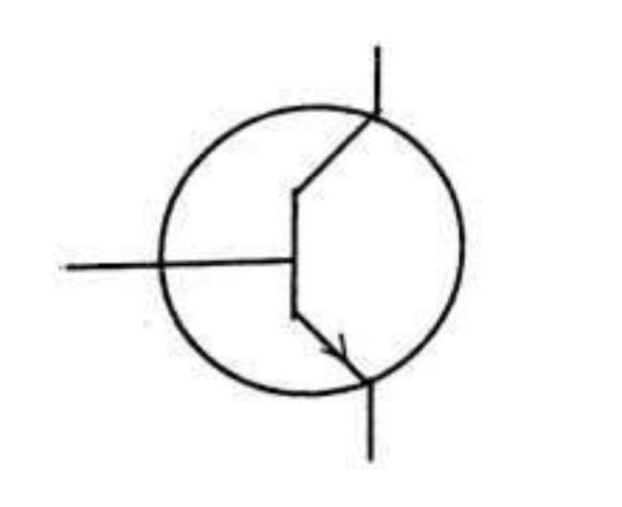
A. electron movement.
B. hole movement.
C. electron and hole movement.
D. negative charge movement.

Answer Key
1. D weevil.  2. A 1/2.  3. D I, II and III.  4. C +1.  5. B mixed cropping.  6. A atomic number.  7. C Sucrose.  8. C proportion of sand, silt and clay in a sample of soil.  9. A swells when dry and shrinks when wet.  10. D nitrogen in the soil.  11. B light to electrical.  12. B small intestine.  13. A comes on and stays on.  14. D enamel.  15. D decrease in intermolecular forces.  16. C Magnetization of iron.  17. C distillation.  18. B Mg²⁺.  19. B afforestation.  20. B Venus and Mercury. | 21. A I only.  22. B pistil.  23. C earth is between the sun and the moon.  24. D I, II and III.  25. A seed formation.  26. C residue and filtrate.  27. A low pressure.  28. C I and III only.  29. D Gravitational force.  30. C upright growth of the plant.  31. B astronauts.  32. A producers.  33. B crow bar.  34. B plumule.  35. C weight.  36. D I, II and III.  37. D 300 m².  38. D waste energy.  39. A A metre-rule.  40. B hole movement.

